PROJECT REPORT

ON

**PetCare Website**

(UNDER THE PARTIAL FULFILLMENT OF THE UNIVERSITY

FOR THE COURSE OF T.Y.BSC

COMPUTER SCIENCE)

**DESIGNED AND DEVELOPED**

BY

**Ishaan**

GUIDED BY

**Dr. Vaishnavi Assar &**

**Ms. Pratiksha Harwalkar**

DEPARTMENT OF COMPUTER SCIENCE

PARLE TILAK VIDYALAYA ASSOCIATION’S

MULUND COLLEGE OF COMMERCE S.N. ROAD,

MULUND (WEST) MUMBAI-80

UNIVERSITY OF MUMBAI

2022-23

**ACKNOWLEDGEMENT**

I have a great pleasure in representing this project report entitled “**Online Grocery Shopping**” and I grab this opportunity to convey my immense regards towards all the distinguished people who have their valuable contribution in the hour of need.

I like to extend my gratitude to our beloved Principal Dr. Sonali Pednekar for her timely and prestigious guidance.

I take this opportunity to thank Ms. Reena Shah, Coordinator of the Department and all the faculty members of the Department of Computer Science of Mulund College of Commerce, for giving me an opportunity to complete this project and the most needed guidance throughout the duration of the programme.

I am extremely grateful to my project guides Dr. Vaishnavi Assar & Ms. Pratiksha Harwalkarfor their valuable guidance and necessary support during each phase of the project. She was the source of continuous encouragement as each milestone was crossed.

A special thanks to the University of Mumbai for having prescribed this project work to me as a part of the academic requirement in the Final year of Bachelor of Science in Computer Science.

Finally, I also owe to my fellow friends who have been a constant source of help to solve the problems that cropped up during the project development process.

Name_of_the_student

Index

|  |  |  |
| --- | --- | --- |
| SR. NO. | TOPIC | PAGE NO. |
| 1. | TITLE | 4 |
| 2. | INTRODUCTION | 5 |
| 3. | REQUIREMENT SPECIFICATION | 10 |
| 4. | SYSTEM DESIGN DETAILS | 13 |
| 5. | SYSTEM ANALYSIS AND IMPLEMENTATION | 22 |
| 6. | RESULTS | 65 |
| 7. | CONCLUSION AND FUTURE SCOPE | 72 |
| 8. | REFERENCES | 76 |
| 9. | ANNEXURE | 77 |

1. Title

Pet Care Website



Plagiarism Checker X Originality Report

**Similarity Found: 7%**

Date: Thursday, September 08, 2022

Statistics: 2084 words Plagiarized / 29058 Total words

Remarks: Low Plagiarism Detected - Your Document needs Optional Improvement.

-------------------------------------------------------------------------------------------

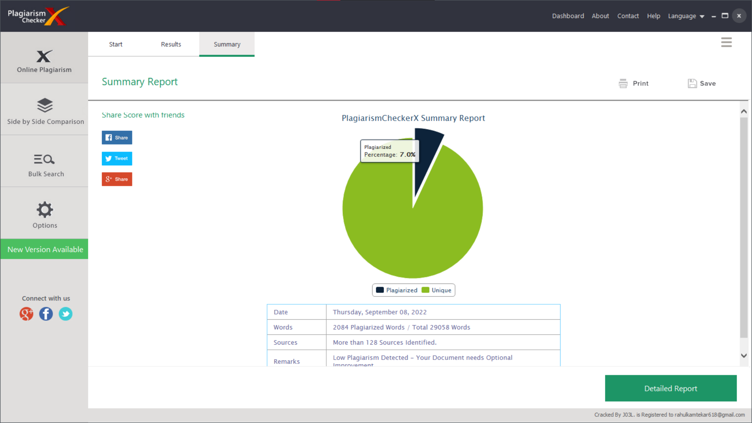

1. **Introduction**
   1. Objective of the project:

* Creating a good community for pet owners.
* Assist them with everything pet-related.
* To provide a place where their pets can be sent.
* To provide a pet-friendly environment.
  1. Description of the current system:
* There isn't a big Web-based pet community.
* Searching for pet drop-off areas is difficult.
* Having difficulty finding pet-friendly accommodations is usual nowadays.
  1. Limitations of current system:
* Searching out such places is time-consuming.
* Limited information available regarding pet-care.
* Not enough transparency is there.
* All the pet related information is not available at one place

2.4 Description of proposed system:

* The application can be used without any special training
* The system will be more accurate and reliable than the current one.
* this website is helping you by gathering all the pet related information you need in one place.
* Achieving more transparency by checking all the pet-drop off areas.

2.5 Advantages of proposed system

* + Reduced time consumption
  + No paper work needed
  + No loss of records
  + Can find what you need quickly

3. **Requirement Specification**

3.1 Software Requirement

* + Operating System – Microsoft Windows 2010
  + Application Software – Front end: HTML, CSS

Back end: SQL

* + Platform – VS CODE

3.2 Hardware Requirement

* + Processor - 1.6 GHz
  + RAM - 4GB or more
  + Disk Space – 3 GB or less

3.3 Data Requirement:

* + Username
  + Password
  + Age
  + Email-address
  + Contact number
  + Address
  + Country
  + State
  + City
  1. Fact finding questions:
  + Why do you want a website for Pet-Care?
* Is it expected to have any future scope?
  + What hardware and software will the system product be set up on?

1. **System Design Details**

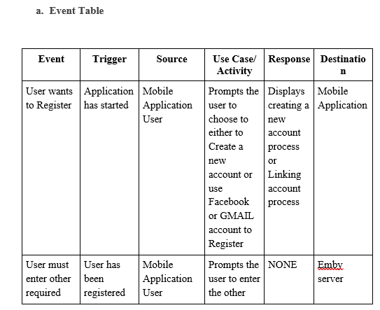4.1 Event Table:

4.2 Class Diagram:

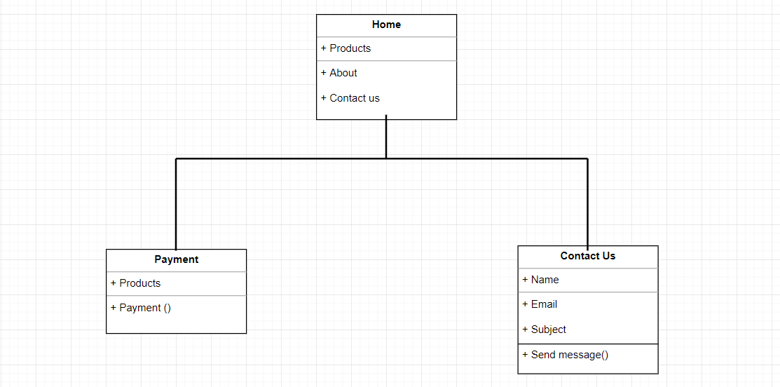

4.3 Use Case Diagram:

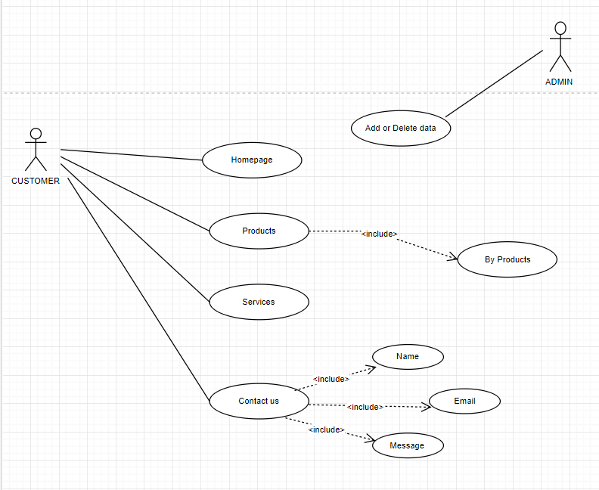

4.4 Sequence Diagram:

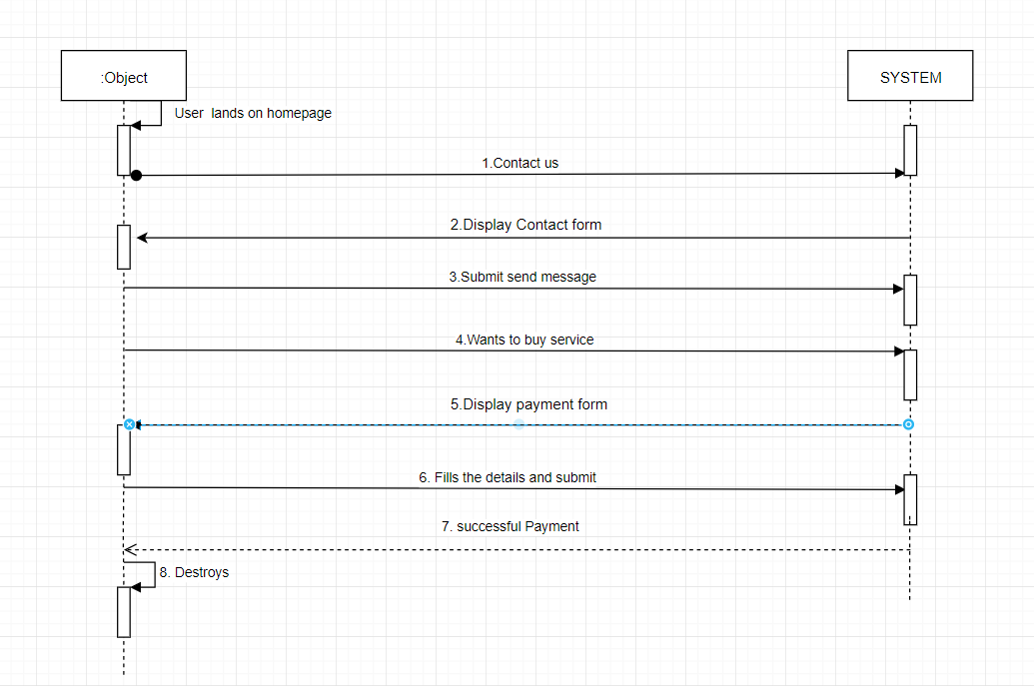

4.5 Activity Diagram:

User Side

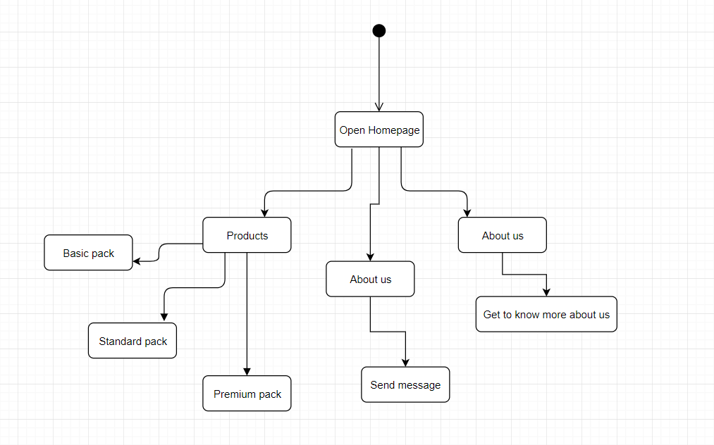

Admin Side

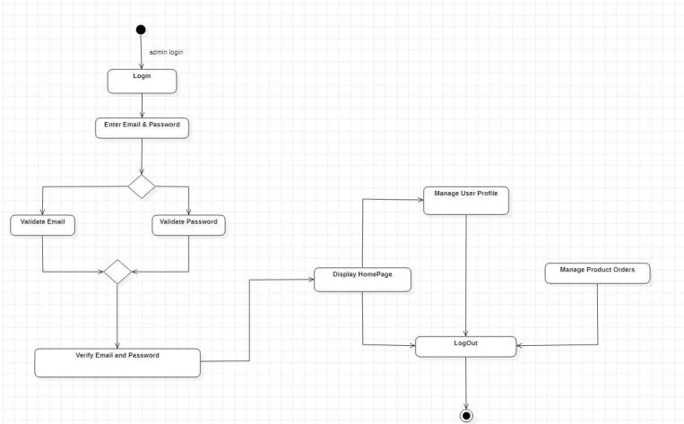

4.6 State Diagram:

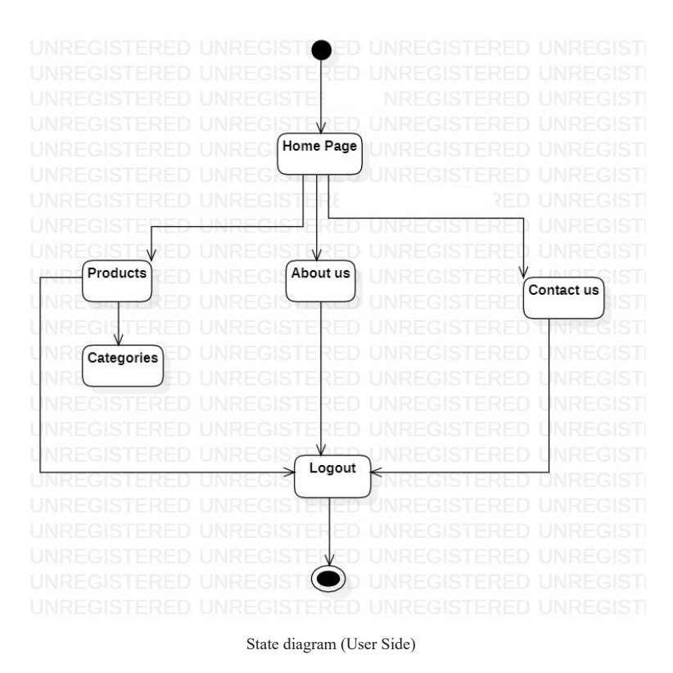

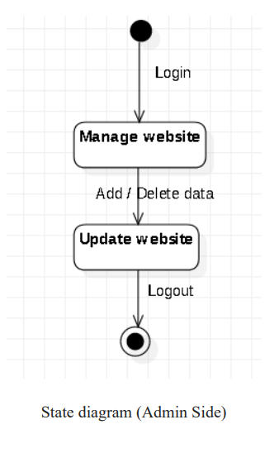

4.7 Package Diagram:

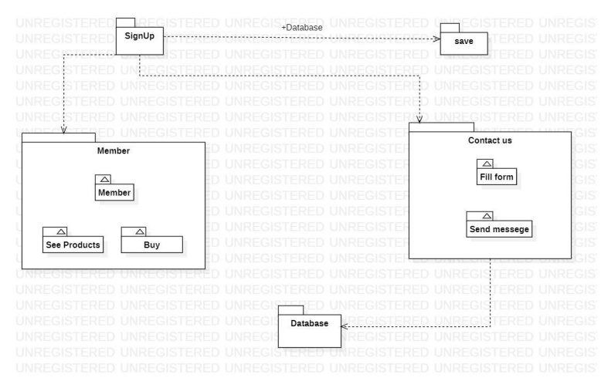

4.8 Component Diagram:

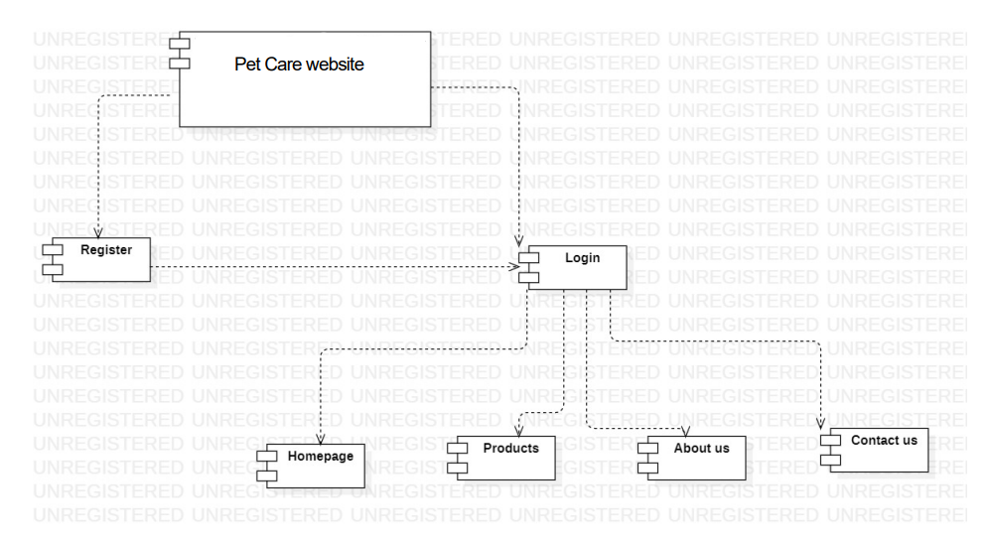

4.9 Deployment Diagram:

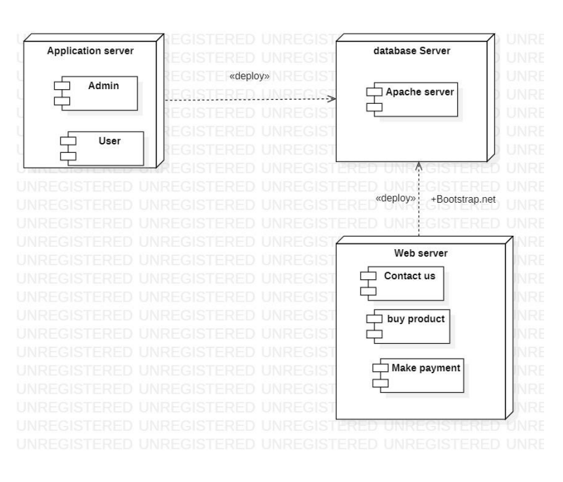

4.10 Database Diagram:

4.10.1 User Login:

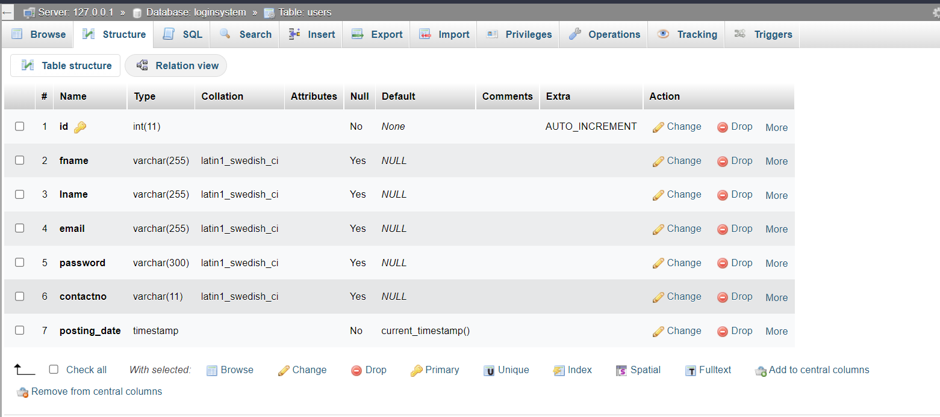

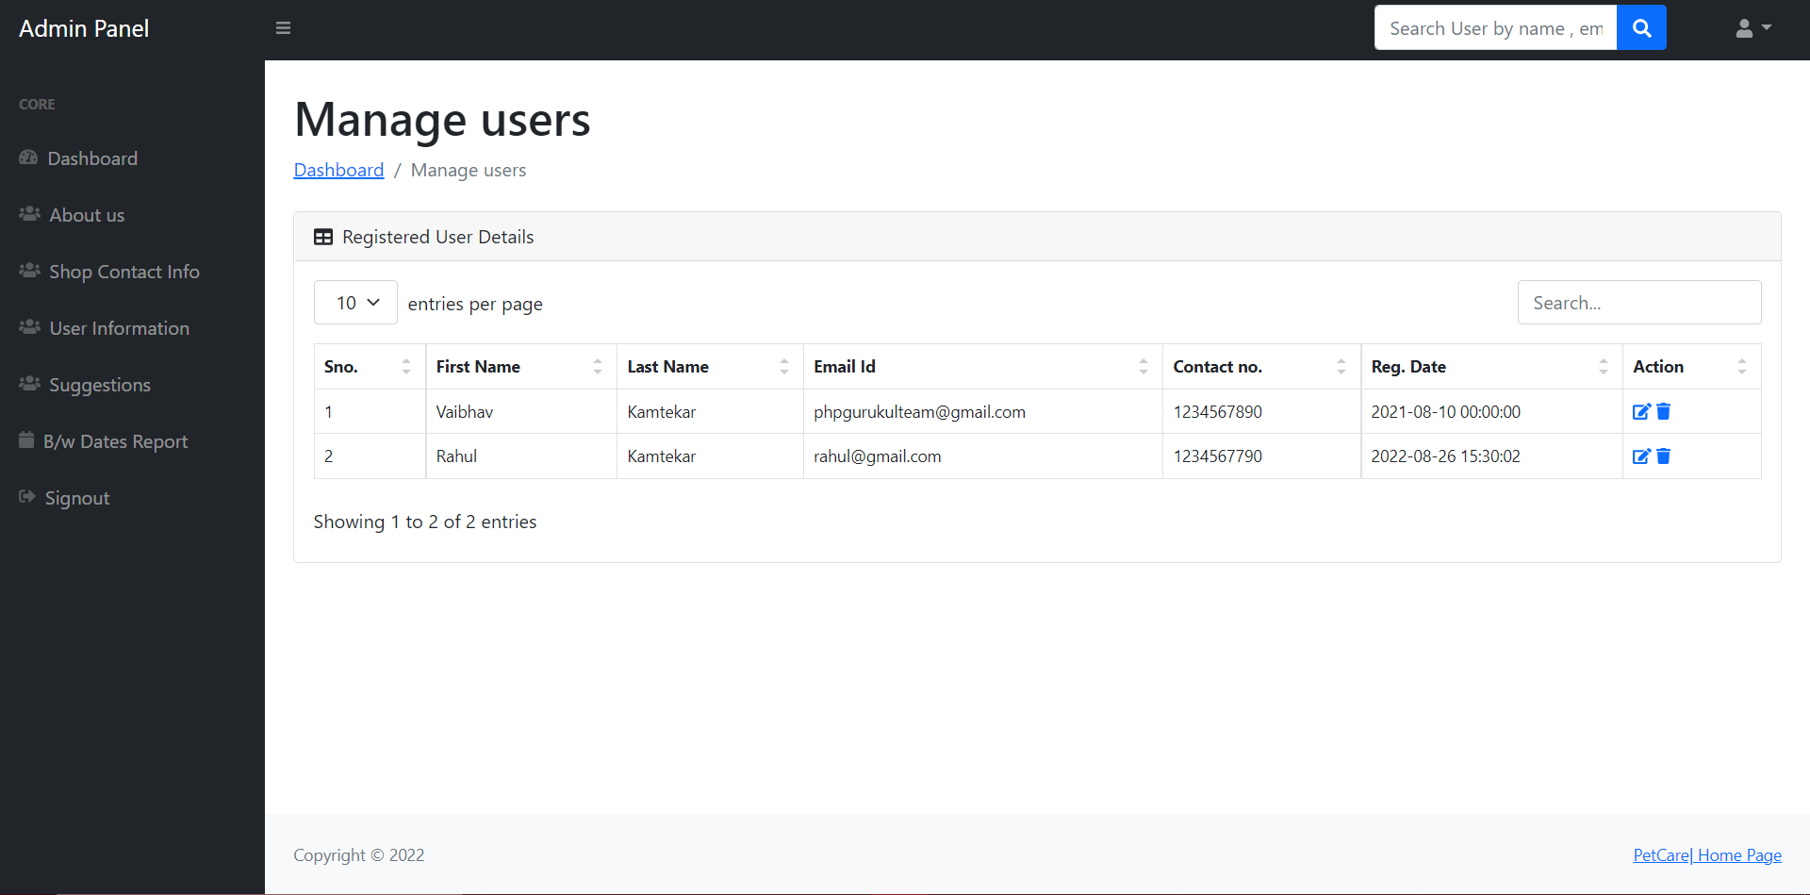

4.10.2 About us:

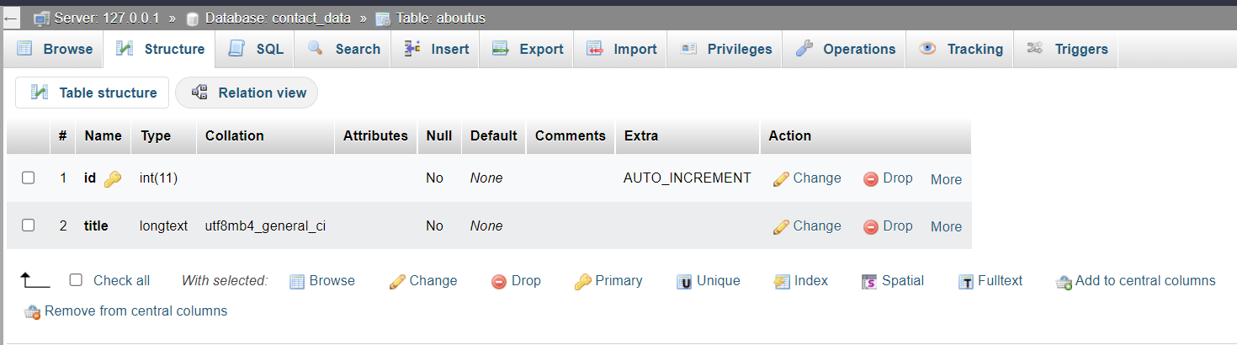

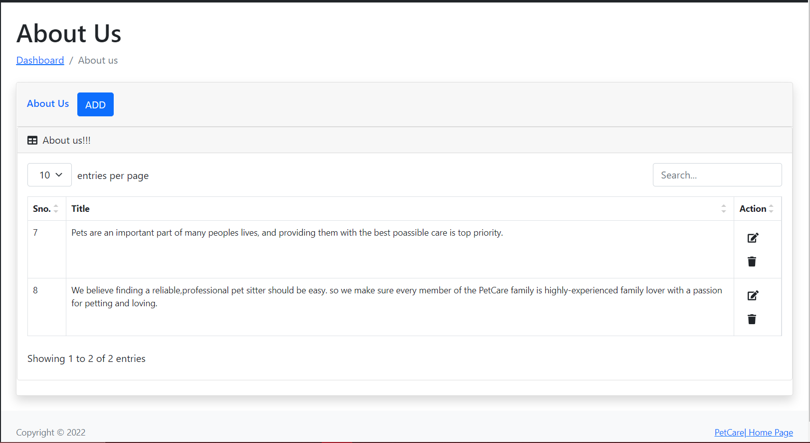

4.10.3 Shop Contact Information:

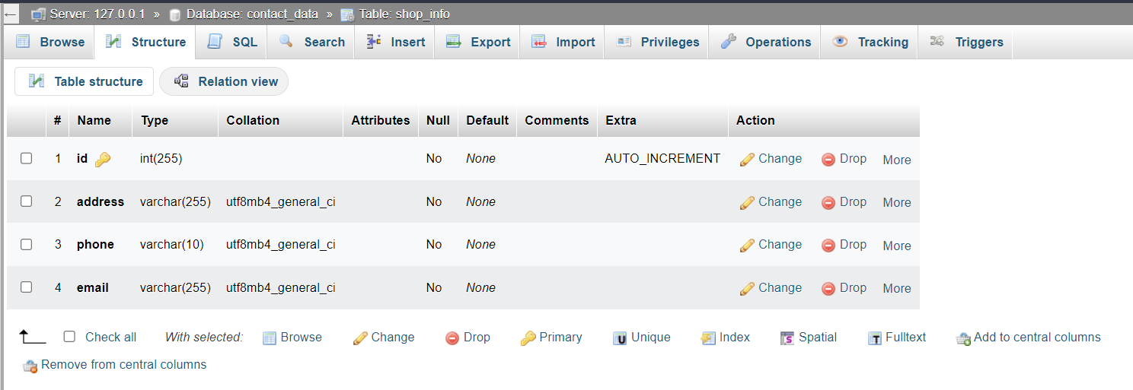

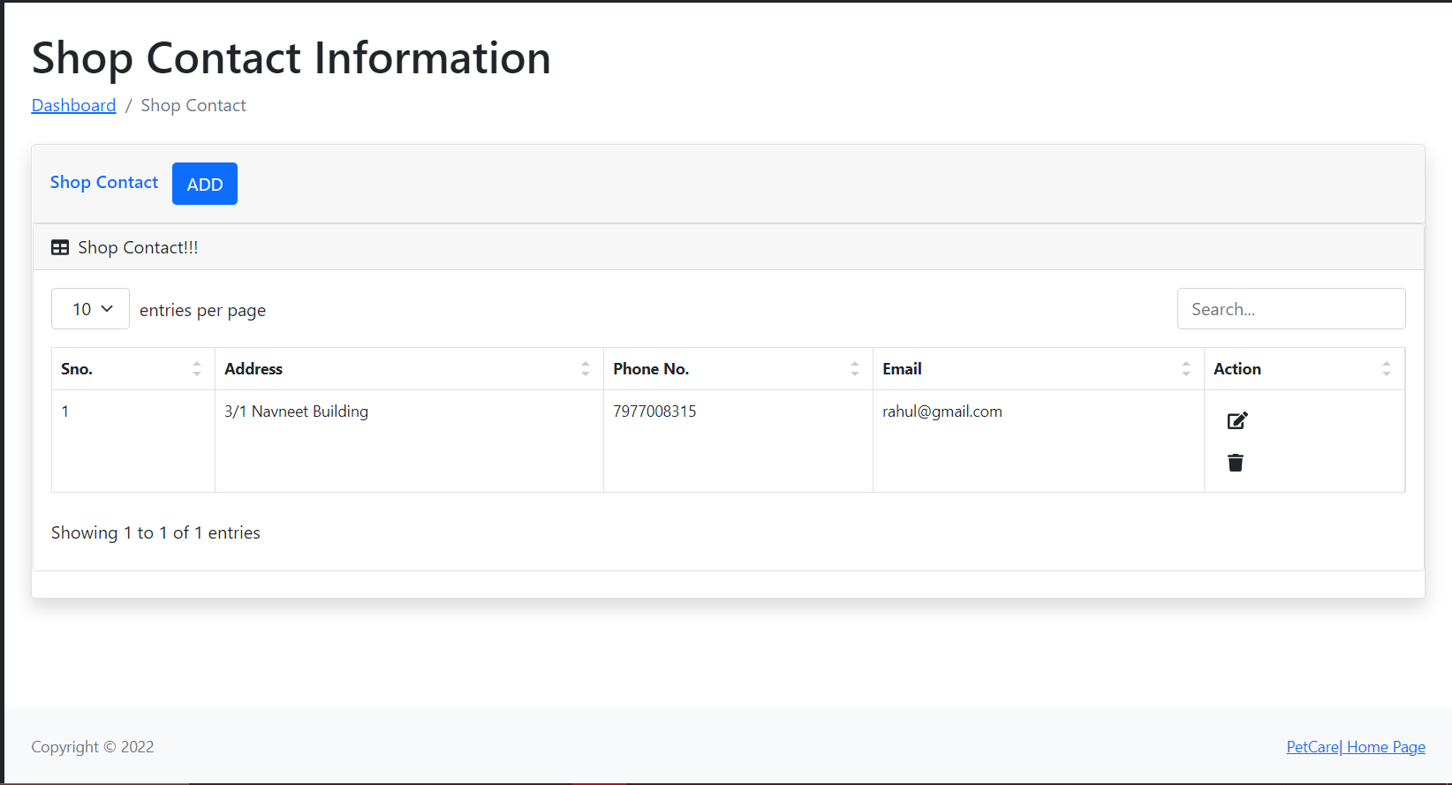

4.10.4 User Information:



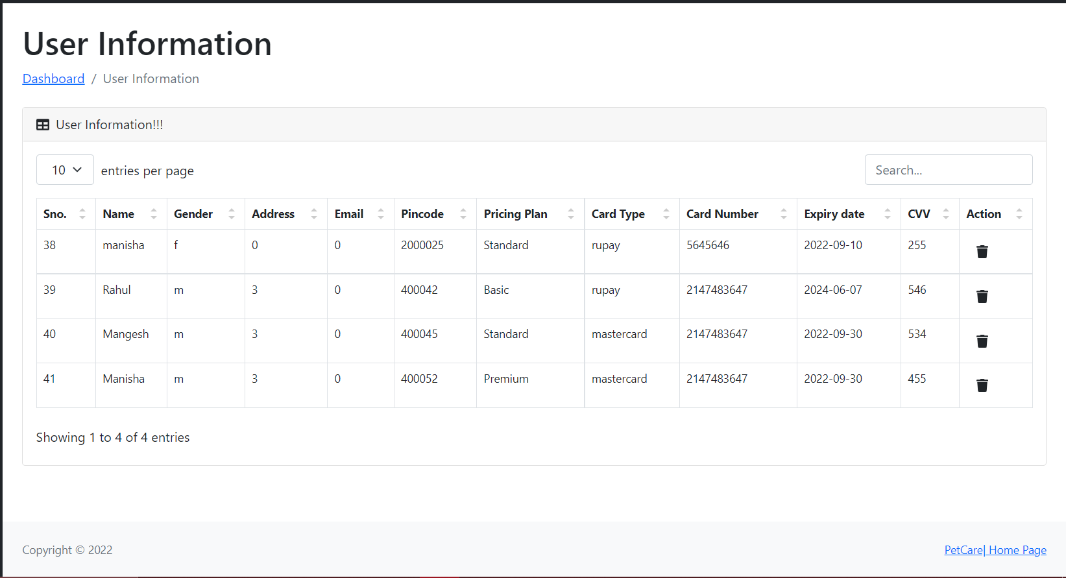

4.10.5 Suggestions:

